**Experiment Title 3.2**

**Student Name: Ishu Rattan UID: 20BCS7755**

**Branch: CSE Section/Group: 20BCS_MM_806 B**

**Semester: 5th Date of Performance: November 7, 2022**

**Subject Name: Machine Learning Lab Subject Code: 20CSP-317**

1. **Aim of the practical:**

Implement Principal Component Analysis.

1. **Objective:**

Implement Principal Component Analysis.

1. **Data Set Chosen:**

Wine Data Set

1. **Source Code and Output:**

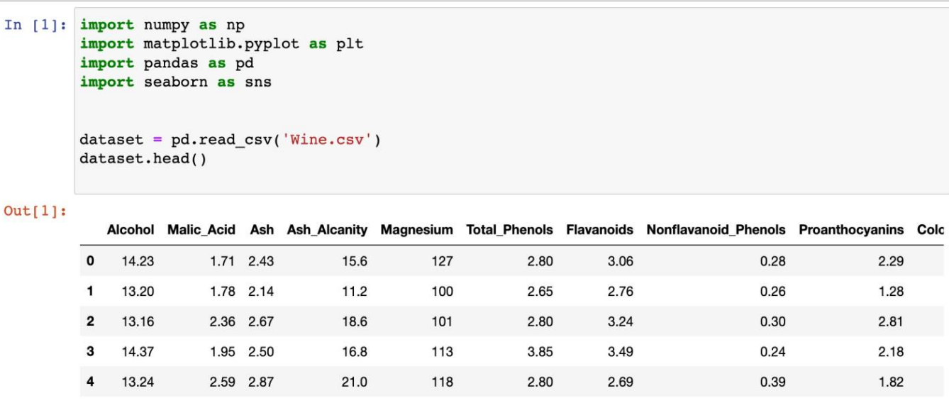

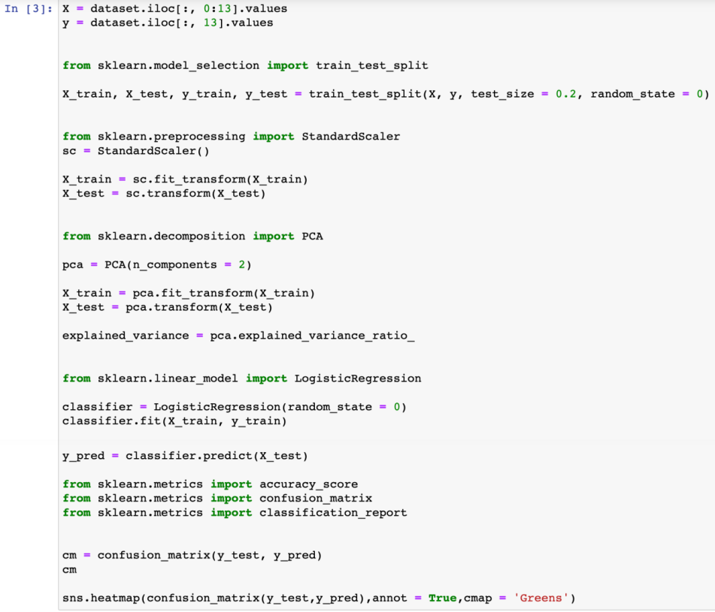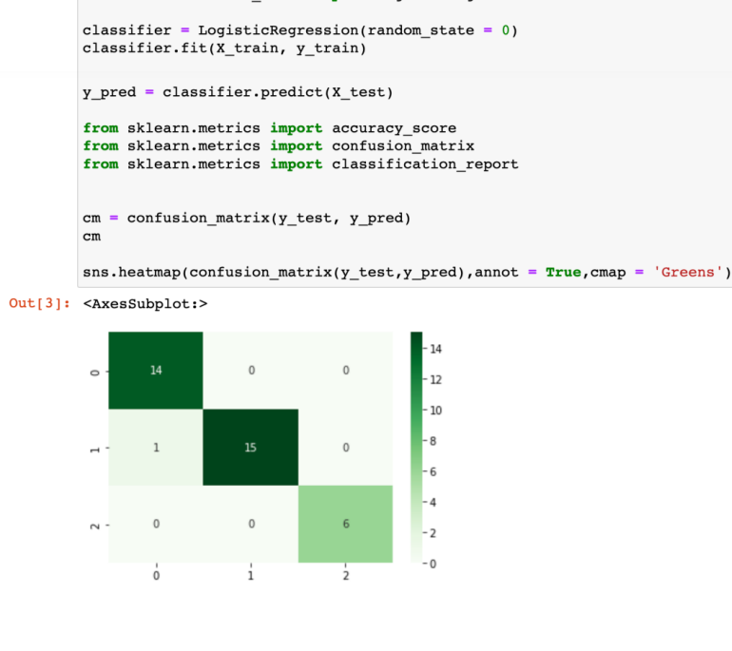

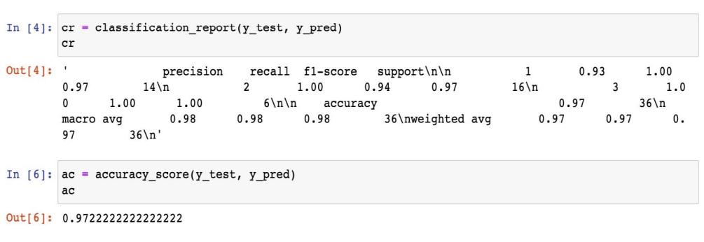

**Result:**

Accuracy of the model is approximately 95%.

**Learning outcomes (What I have learnt):**

1. Learnt about using different libraries.

2. Learnt about Principal Component Analysis.

**Evaluation Grid:**

|  |  |  |  |
| --- | --- | --- | --- |
| **Sr. No.** | **Parameters** | **Marks Obtained** | **Maximum Marks** |
| **1.** | **Student Performance  (Conduct of experiment) objectives/Outcomes.** |  | **12** |
| **2.** | **Viva Voce** |  | **10** |
| **3.** | **Submission of Work Sheet (Record)** |  | **8** |
|  | **Total** |  | **30** |